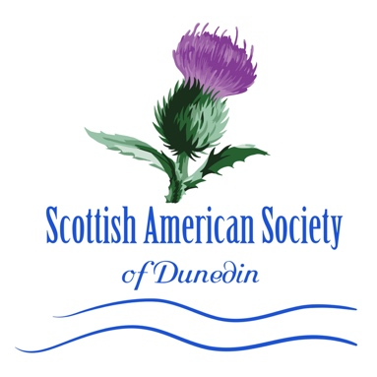
Become a member of the
Scottish American Society
of Dunedin.

Membership at every level.
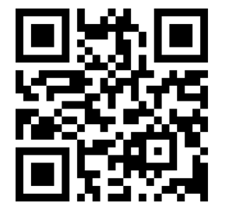
In 1899, the City of Dunedin was founded by two Scotsmen. The name comes from Dun Eideann, the Scottish Gaelic name for Edinburgh, the capital of Scotland. Sister City to Stirling, Scotland, Dunedin, Florida has maintained and embraced its Scottish Roots. Established in 1979 as a 501c3 organization, the Scottish American Society of Dunedin has been committed to supporting the Scottish Arts in Dunedin and preserving our heritage. Many of our members hail from the British Isles adding their knowledge of the customs and traditions we all enjoy. Your membership greatly helps us continue our programs and subsidize the many classes we hold at the Scottish Cultural Center. We hold classes in Scottish highland dance, bagpipes and a weekly genealogy work group.

The Scottish American Society of Dunedin welcomes you to participate in celebrating Scottish traditions at our Scottish Cultural Center located at 917 Louden Avenue, a building which was designated a Historic Landmark by the City of Dunedin. Our annual Scottish traditional events include Highland Dancers, Bagpipes and include:
- Hogmanay (New Year’s Eve)
- Scottish Ceilidhs
- Whisky Tastings

- Robert Burns Night (January)
- Tartan Week (celebrating Tartan Day in April)
- St. Andrew’s Night (November)
- Celtic Christmas Concert

We also present a series of Celtic Concerts which feature the best in Celtic Music from Scotland, Ireland, Canada and the USA! Our members also participate together in events in the City of Dunedin (Mardi Gras Parade, Blue Jays Celtic Night, Holiday Parade and more) and we’d love you to join us. We offer Friday morning Coffee & Craic and Friday evening Happy Hours! Please drop in and get to know us and each other.

All memberships are Annual and renewable every 12 months.

_______ Adult Membership ($25 Single) _______ Adult Membership ($75 Balmoral Single)
_______ Adult Membership ($40 Couple) _______ Adult Membership ($140 Balmoral Couple)
Balmoral membership entitles you to a free ticket/or pair
to a Celtic Concert of your choice!

Name: _______________________________________ (Include Spouse/Partner name if Couple)

Address: ______________________________________ City/State/Zip:__________ Phone: ______________________

Email: ____________________________________________ MUST include email to receive E-Newsletter.
PLEASE PRINT YOUR EMAIL LEGIBLY SO WE CAN READ IT! Thank You!

Additional Email (if couple) for E-Newsletter: __________________________________________
Please mail Check or Credit Card Information (including 3-dig #, Expiration date and Billing Zip code) to: SAS Membership Chair, Post Office Box 2606, Dunedin, FL. 34697.
THANK YOU FOR YOUR MEMBERSHIP!

